Project Design Phase-II
Technology Stack (Architecture & Stack)

Date | 19 February 2026
Team ID | LTVIP2026TMIDS88771
Project Name | Online Payment Fraud Detection using Machine Learning
Maximum Marks | 4 Marks

Technical Architecture:
The Deliverable shall include the architectural diagram as below and the information as per the table1 & table 2
Example: Order processing during pandemics for offline mode
Reference: https://miro.com/templates/architecture-diagram/
Guidelines:
Include all the processes (As an application logic / Technology Block)
Provide infrastructural demarcation (Local / Cloud)
Indicate external interfaces (third party API’s etc.)
Indicate Data Storage components / services
Indicate interface to machine learning models (if applicable)
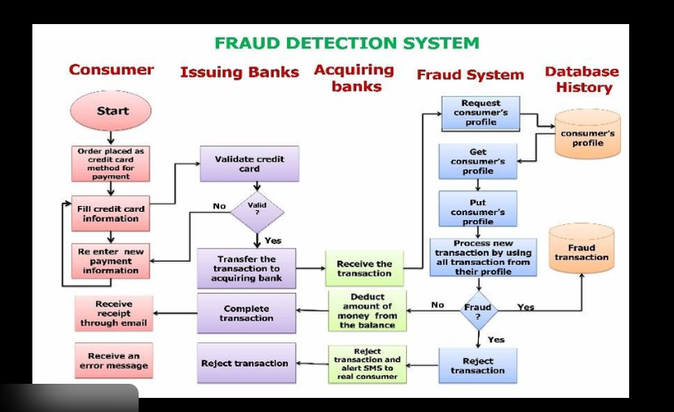

Table-1 : Components & Technologies:
S.No | Component | Description | Technology
 | User Interface | Web interface for users & admin | HTML, CSS, JavaScript, React
 | Application Logic-1 | Transaction processing logic | Python (Flask/Django)
 | Application Logic-2 | Data preprocessing & feature engineering | Pandas, NumPy
 | Application Logic-3 | Fraud detection model integration | Scikit-learn / TensorFlow
 | Database | Stores transaction & user data | MySQL.
 | Cloud Database | Cloud storage for scalability | AWS RDS
 | File Storage | Log & dataset storage | AWS S3
 | External API-1 | SMS Alert API | Twilio API
 | External API-2 | Email Notification API | SMTP / SendGrid
 | Machine Learning Model | Predicts fraud transactions | Random Forest / XGBoos
 | Infrastructure (Server / Cloud) | Cloud deployment:
  AWS EC2

Table-2: Application Characteristics:
S.No | Characteristics | Description | Technology
 | Open-Source Frameworks | ML & backend frameworks | Python, Scikit-learn, Flask
 | Security Implementations | Data encryption & hashing | SHA-256, HTTPS, SSL
 | Scalable Architecture | 3-Tier Architecture | AWS Cloud
 | Availability | 24/7 cloud availability | Load Balancer
 | Performance | Fast fraud detection (<2 sec) | Caching, Optimized ML model

References:
https://c4model.com/
https://developer.ibm.com/patterns/online-order-processing-system-during-pandemic/
https://www.ibm.com/cloud/architecture
https://aws.amazon.com/architecture
https://medium.com/the-internal-startup/how-to-draw-useful-technical-architecture-diagrams-2d20c9fda90d

